ECEN5730-PCB Board-3 Report

# Project Overview

## POR

1. Converting 5 V in to 3.3 V using LDO
2. Adding Atmega328 microcontroller
3. Adding CH340g USB to UART interfacing chip
4. Adding a 16 MHz crystal resonator for generating a clock and a 12 MHz resonator for the CH340g.
5. Adding appropriate decoupling capacitors close to the ICs
6. Adding a connector for the SPI and boot loading pins
7. Adding a TVS chip to protect the data pins from ESD
8. Adding power from the USB plug
9. Adding a reset switch with a debounce capacitor
10. Adding header sockets that match the location of the standard Arduino board so that shield can be plugged
11. Adding a ferrite filter on the AVCC pin to the ADC circuit on the 328
12. Adding 0.5 ohm series resistor in the power rail and connectors to measure the power supply current.
13. Adding provision to select the power supply either from a 5v external AC to DC converter or from a USB connector
14. Adding additional rows of ground pins adjacent to and spaced 300 mils center to center from digital io switching pins to reduce cross talk for I/O pin switching.
15. Adding continuous return plane for the golden Arduino
16. There would be test points for:
    1. oscillator
    2. Reset pin
    3. The 3.3. V rail on the board
    4. The 5 V rail on the board
17. For Risk reduction digital circuit was isolated from the power conditioning unit
18. It was also noted that internal oscillator of Atmega328 can be used in case oscillator circuit does not work

## What it means to work:

### Power supply:

1. Check visually if LED for power is turned on
2. Measure the voltage of power rail on oscilloscope using 5V test point. Voltage should be around 5V.
3. Measure the voltage of power rail on oscilloscope using 3V3 test point. Voltage should be around 3.3V.

### Oscillators:

1. Around 16 MHz frequency available at Arduino’s oscillator
2. Around 12 MHz frequency available at CH340g chip’s oscillator

### Arduino Bootloader:

1. One should be able to flash bootloader into arduino board using Arduino IDE and commercial Arduino as ISP

### Programming the arduino:

1. One should be able to flash program into arduino board

### Switching noise comparison:

1. It is expected to have lower switching noise on Golden arduino compared to commercial Arduino.

## Sketch of the schematic:

Actual schematic capture from Altium designer

* Schematic was divided into functional sections: power conditioning, USB to UART circuit, Microcontroller and LEDs and switches
* PowerTrace class was used to set 20 mils of power lines in layout
* Appropriate isolation switches, LEDs and test points were used at required locations. This helped in risk reduction as these functionality act as debug pointers.

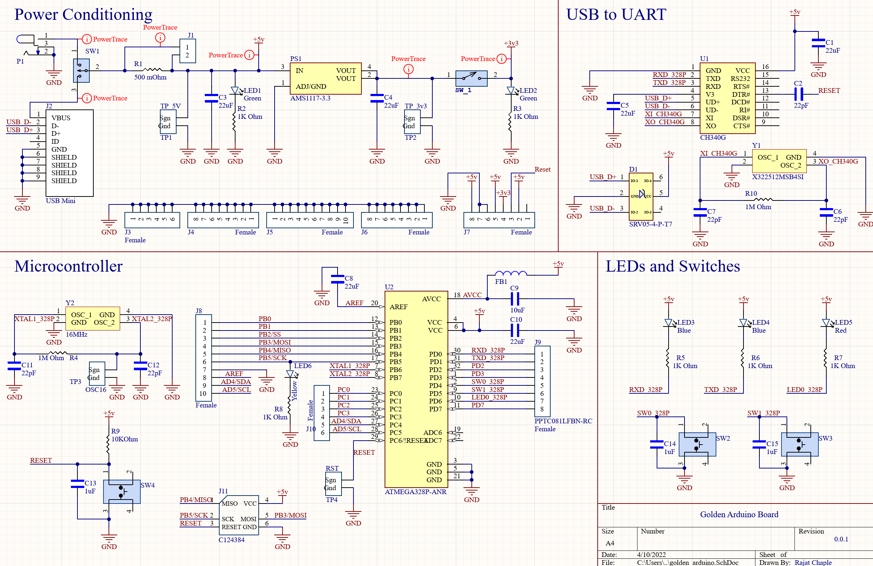

* Things done right
  + Every signal has a Net Label
  + Direction of power is appropriate i.e. 5v is at the top and ground is at the bottom.
* Things did not go the right way
  + Filter capacitor on chip CH340g for reset circuit should have been 22uF. This was a hard error. 22pF was replaced with 22uF.
  + This capacitor had 0402 package. It was challenging to solder 1206 part in place of these 0402 solder pads.

## Board layout from Altium designer

* Appropriate design rules were set before starting the layout. E.g. via diameter, Thermal relief.
* Name, board ID was used as board identification
* Continuous ground plane was added at the bottom layer
* Crossunders were kept below a length of ½ inch
* Decoupling caps were placed close to the ICs

Top Layer

Bottom Layer

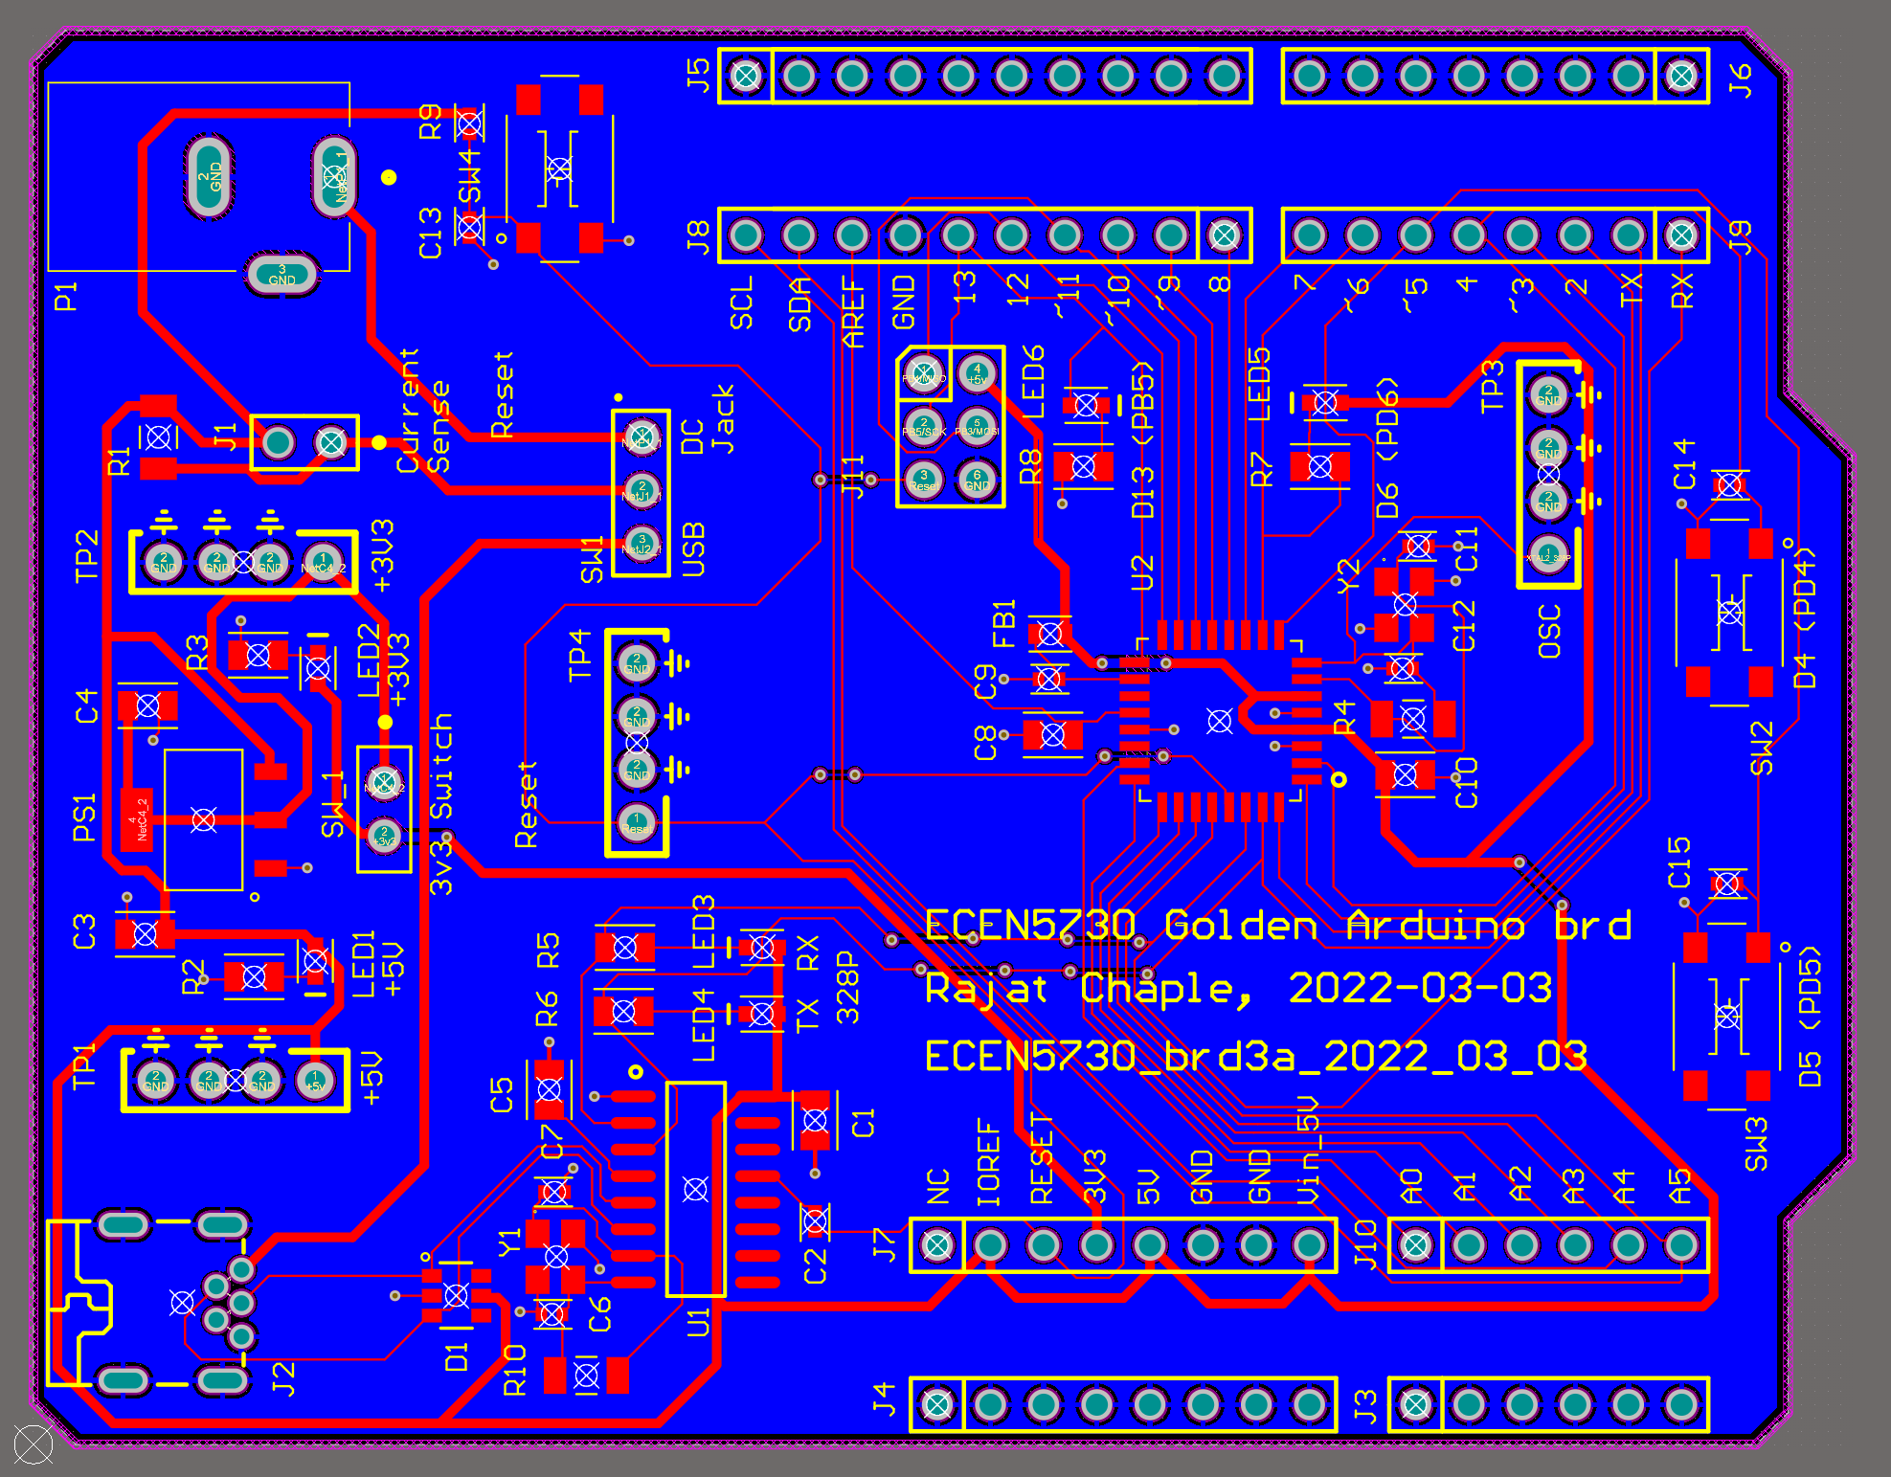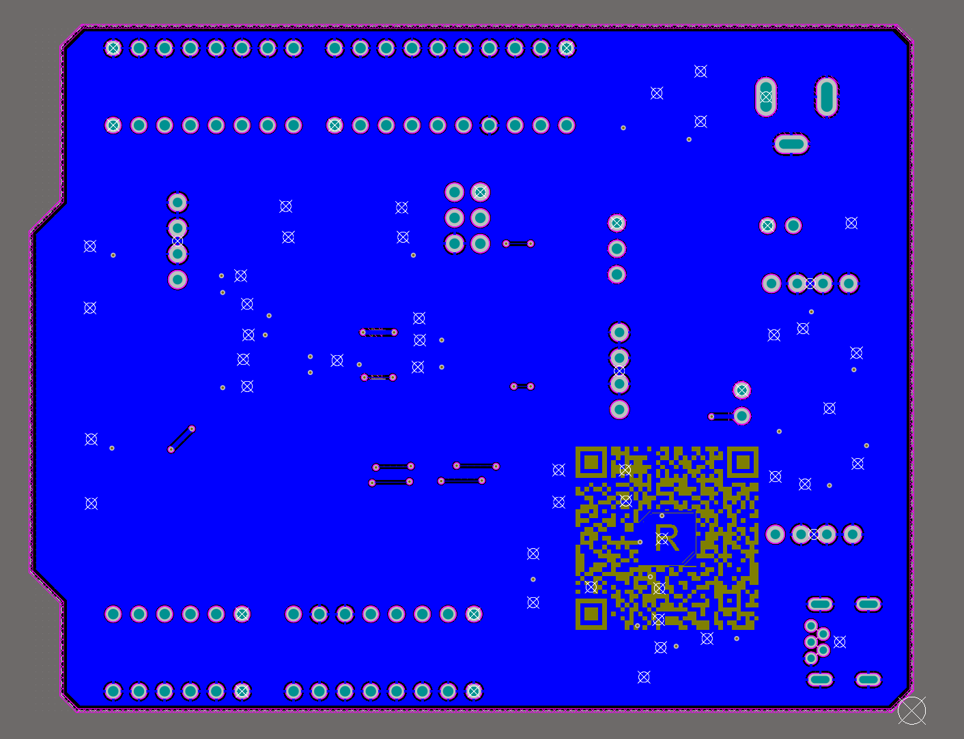

## Assembled board

* Board was powered ON using 5v adapter or USB port
* Board has a provision to be powered on either from USB port or from a DC jack
* Board also has a provision of 2 custom switches (with debounce circuit) and 2 custom LEDs.

Top Layer

Bottom Layer

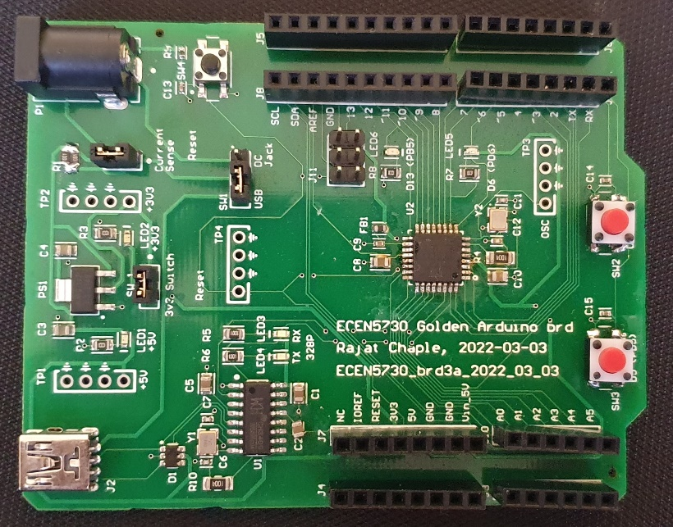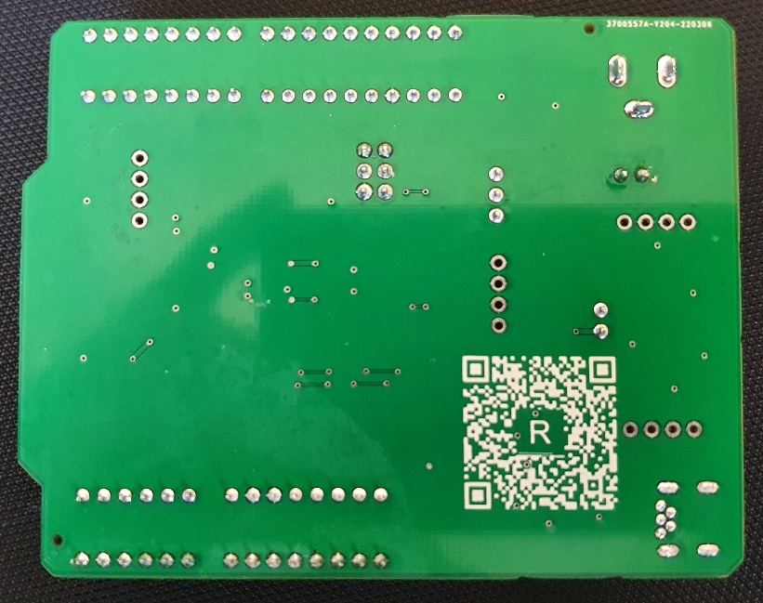

# What worked

## Your definition of what it means to work

For this lab, these are the criteria:

### Power supply:

1. Check visually if LED for power is turned on
2. Measure the voltage of power rail on oscilloscope using 5V test point. Voltage should be around 5V.
3. Measure the voltage of power rail on oscilloscope using 3V3 test point. Voltage should be around 3.3V.

### Oscillators:

1. Around 16 MHz frequency available at Arduino’s oscillator
2. Around 12 MHz frequency available at CH340g chip’s oscillator

### Arduino Bootloader:

1. One should be able to flash bootloader into arduino board using Arduino IDE and commercial Arduino as ISP

### Programming the arduino:

1. One should be able to flash program into arduino board

### Switching noise comparison:

1. It is expected to have lower switching noise on Golden arduino compared to commercial Arduino.

## Your expectations for any performance features

* + - Switching noise on Golden Arduino as compared to commercial Arduino
      * There would be more switching noise on golden Arduino because of
        + Cuts in the ground plane
        + Very few ground pins and apart from signal pins

## What you actually measured to verify your board “worked”

In order to verify that board is working, following tests were considered.

1. Arduino is detected as CH340 under Ports

1. 5v and 3v3 LEDs were turned on

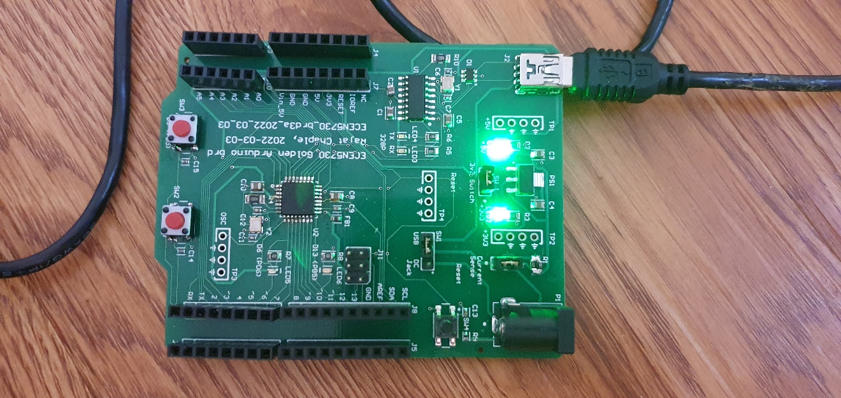

5v LED

3.3v LED

Voltages were also measured using test points on multimeter.

1. Bootloader was flashed successfully to golden Arduino. However, there was an issue where ICSP header pins of commercial Arduino did not work to burn bootloader into golden Arduino. SPI pins on the commercial arduino’s side header was used to resolve this issue.

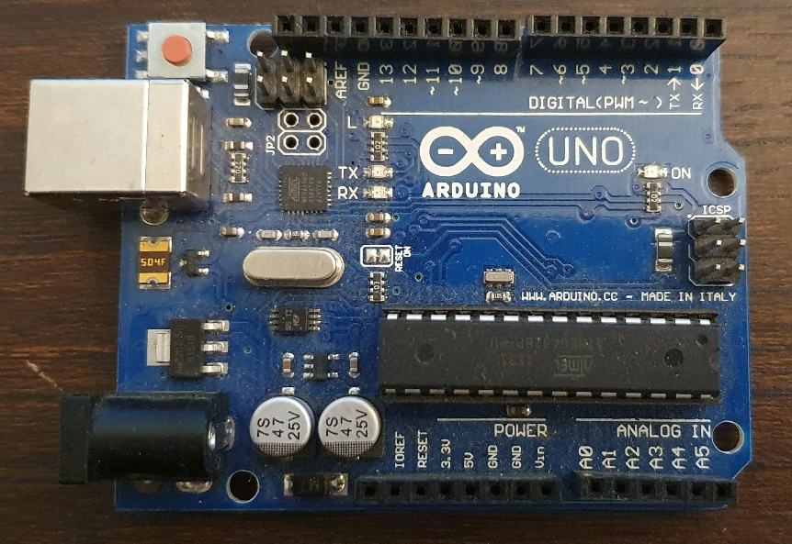

1. Once bootloader was flashed, application code (blink.ino) was flashed into golden Arduino using Arduino IDE successfully.

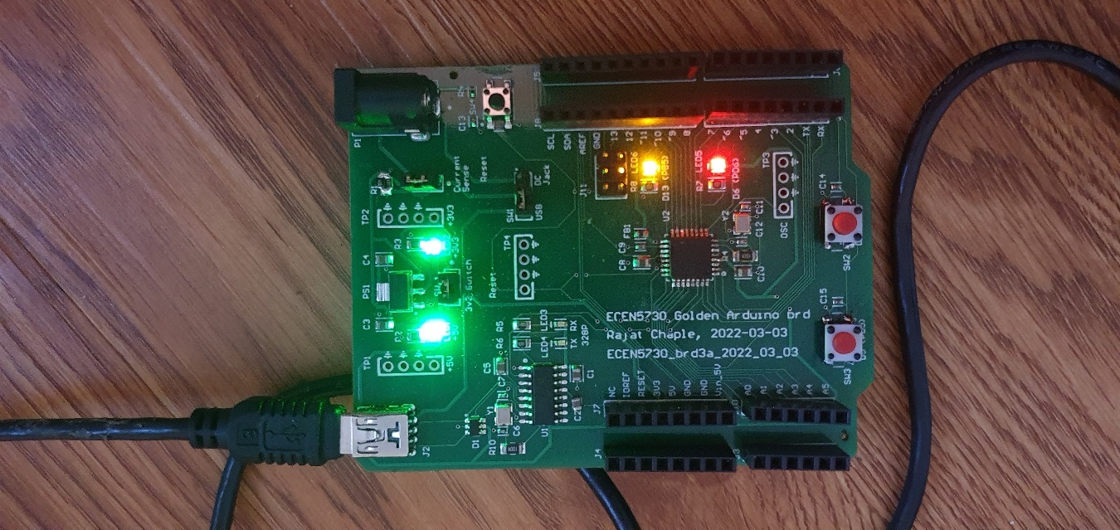

* + - Measurements and Analysis
  + When the three I/O were switching, what was the total current switching, and the rise time?

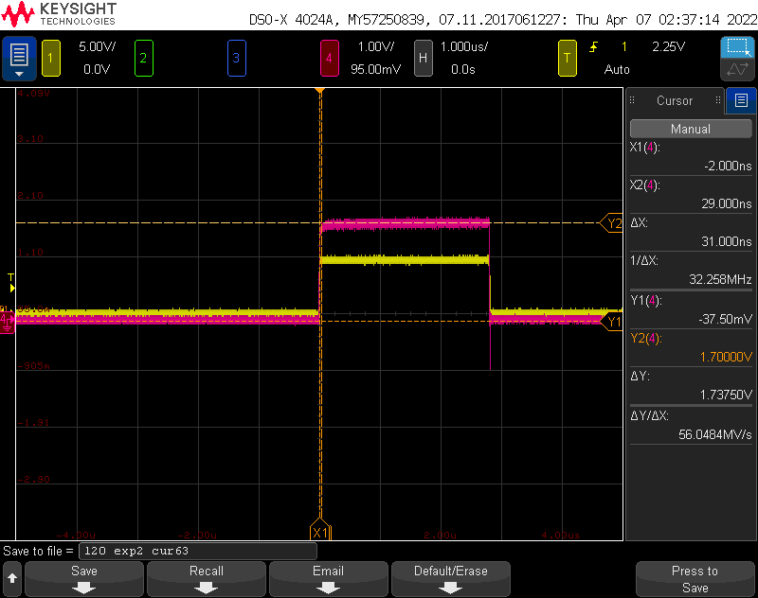

Current through one of the IOs:

$=\frac{1.7375v}{63 ohm}$ $=27.5 mA$

Current through 3 switching IOs: $=3*27.5$ $=82.5 mA$

Rise time = 9.766 nsec

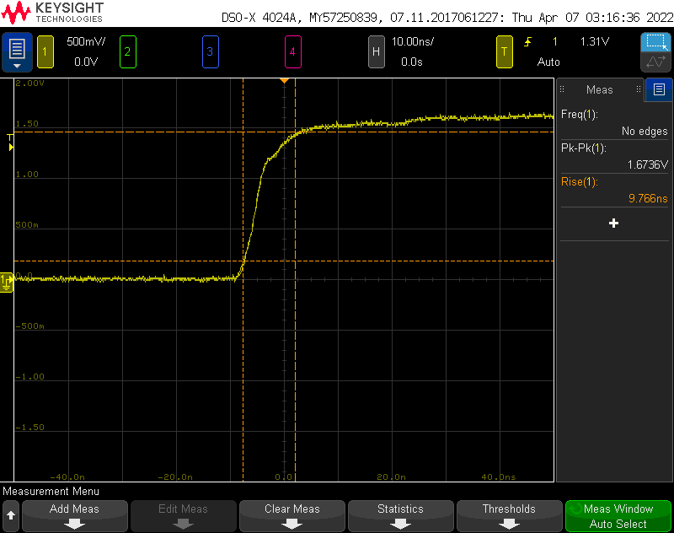

* + What was the quiet HIGH and quiet LOW noise on the die for the rising edge?

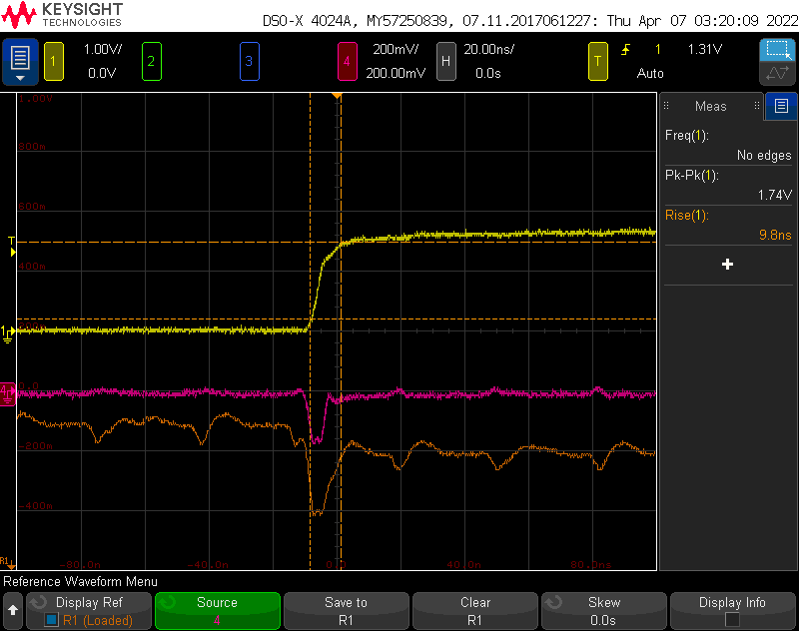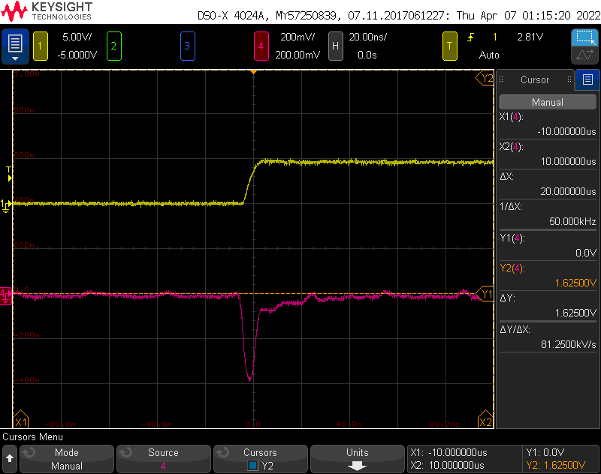

For golden Arduino: Noise on Quiet High is around 250mV and that on Quiet low is around 200mV

Whereas, For Commercial Arduino, noise on Quiet high is around 500mV and that on Quiet Low is around 400mV. This is because of bad design practices (Ground bounce).

Golden Arduino (Qlo, Qhi)

Commercial Arduino (Qlo)

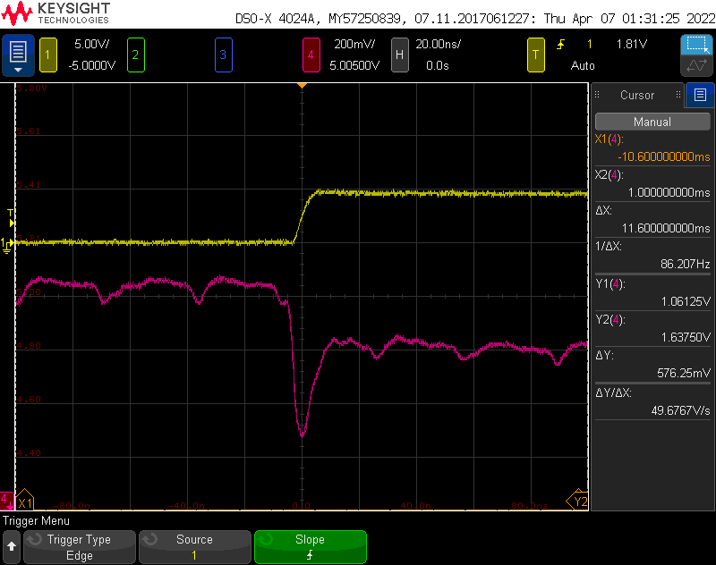

Commercial Arduino (Qhi)

* + Do the same analysis for the falling edge. Any comments amount this noise?

For golden Arduino: Noise on Quiet High is around 250mV and that on Quiet low is around 500mV

Whereas, For Commercial Arduino, noise on Quiet high is around 400mV and that on Quiet Low is around 450mV. This is because of bad design practices (Ground bounce).

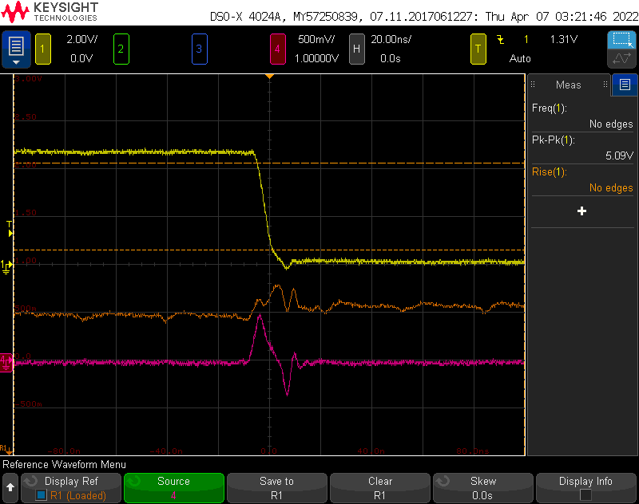

Golden Arduino (Qlo, Qhi)

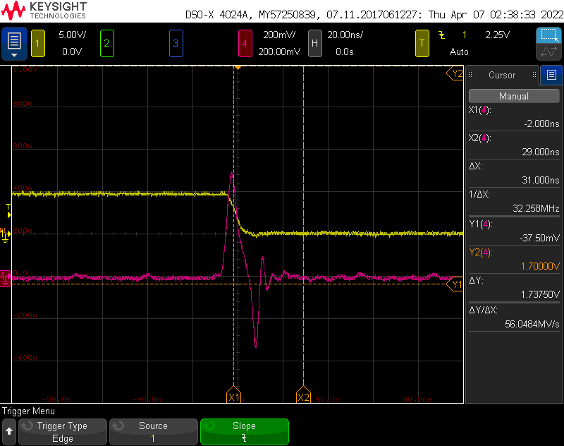

Commercial Arduino (Qlo)

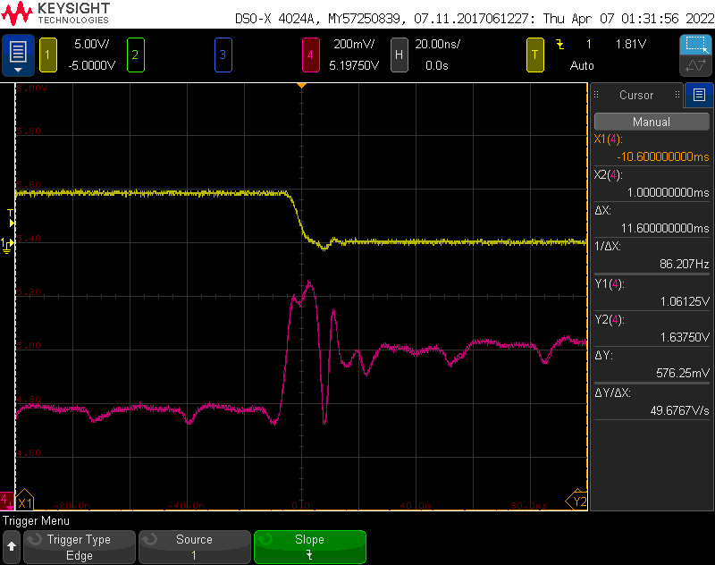

Commercial Arduino (Qhi)

* + When the I/O current was switching, what was the difference in switching noise on the 5 V rail on the die and on the board? Compare the two on the same plot.

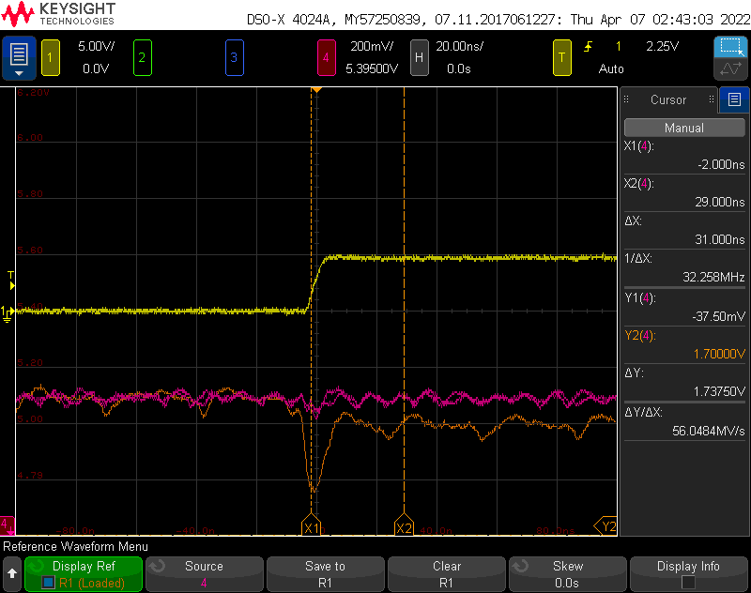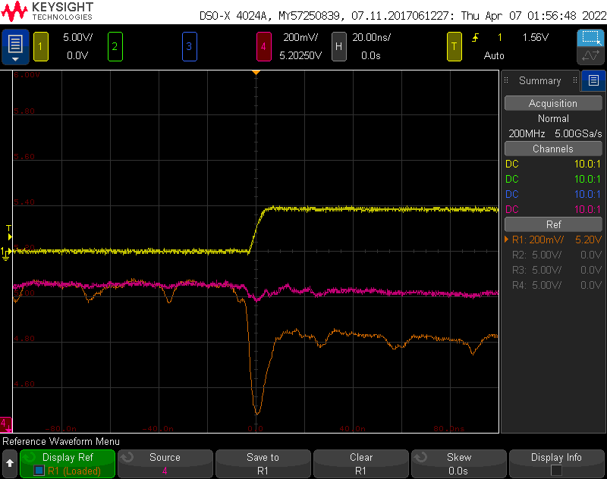

When IO was switching, noise on 5V rail is around 40mV and that on Quiet high is around 500 mV for commercial board. For Golden Arduino noise on Quiet high line is around 300 mV.

Commercial Arduino (5v rail, Qhi)

Golden Arduino (5v rail, Qhi)

* + When the slammer circuit triggered, what the was current flowing through the 5 V rail on the die? What was the duration and the rise time?

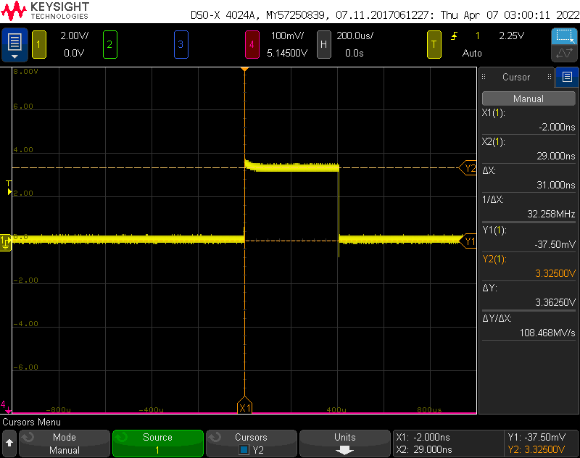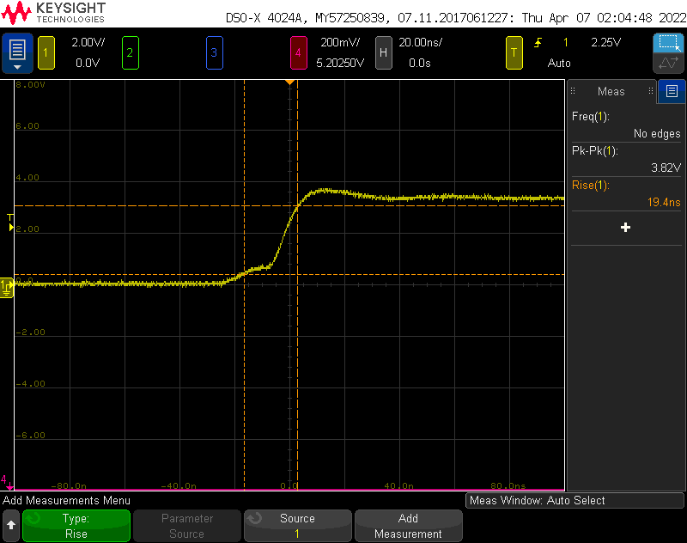

Current flowing through 5V rail = (3.36250v) / (10ohm) = 336.25mA

Rise time is 19.4 nsec

* + What was the voltage drop on the 5 V rail at steady state and the current flow? What does this suggest as the output Thevenin source resistance of the 5 V power rail?



Thevenin resistance = $$V_{th} =5000 mV$$

 

$$V_{load}=3362 mV$$

$$R_{L}=10Ω$$

Calculating for Rth,

Voltage drop = 1.64v

* + What was the switching noise on the 5 V rail during the rising edge? On the quiet HIGH rail on the die?

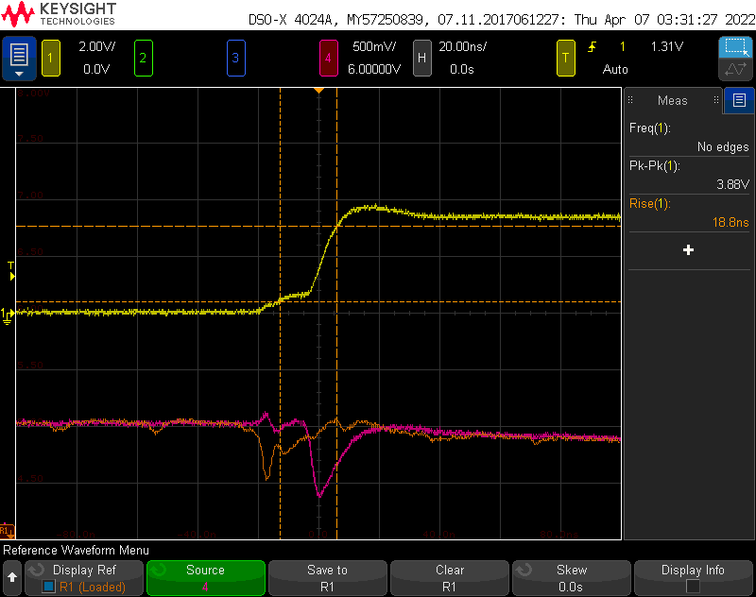

Commercial Arduino (5v rail, Qhi)

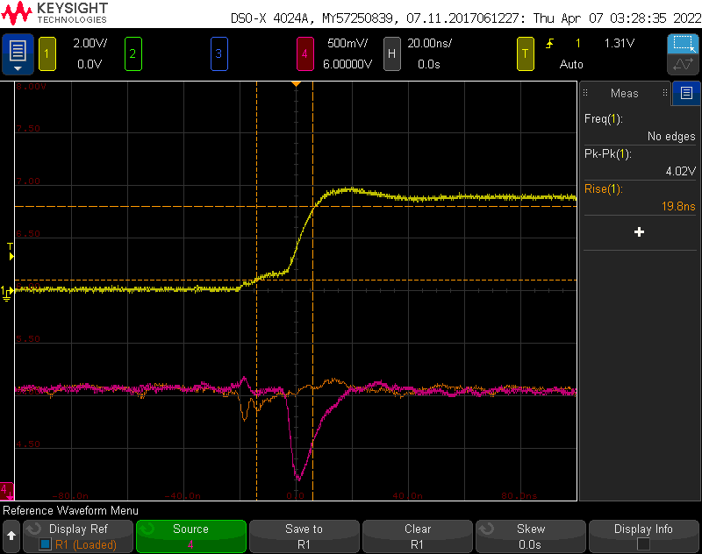

Golden Arduino (5v rail, Qhi)

It can be observed that noise on Quiet high is more (around 500 mV) on commercial Arduino as compared to Golden Arduino (around 200mV). This crosstalk is because of bad design practice in commercial Arduino.

* + What was the switching noise on the 5 V rail during the falling edge? On the quiet HIGH rail on the die?

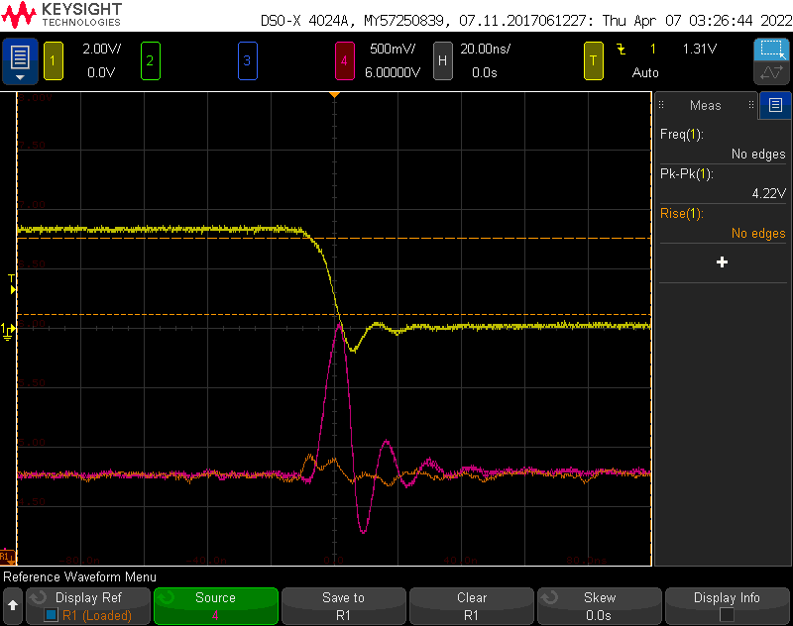

Golden Arduino (5v rail, Qhi)

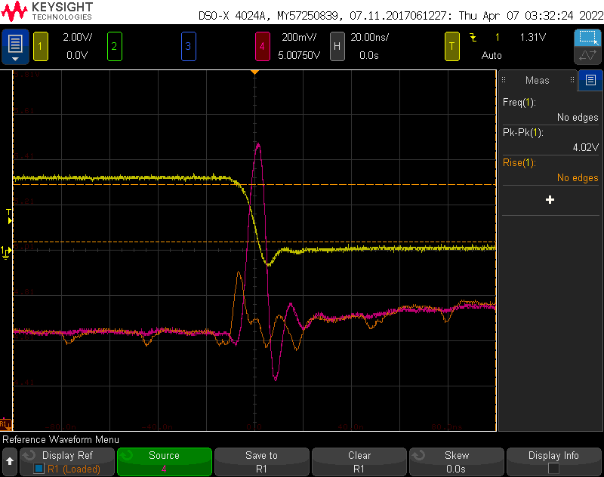

Commercial Arduino (5v rail, Qhi)

It can be observed that noise on Quiet high is more (around 300 mV) on commercial Arduino as compared to Golden Arduino (around 180mV). This crosstalk is because of bad design practice in commercial Arduino.

* + What do you conclude about noise on the die getting onto the board and noise on the board getting on the die?

Noise onto die gets into board because of ground bounce and non-continuous return plane in commercial arduino. Noise induced is considerably low in golden arduino because of good design practices.

* + Near field emission from bottom of the board

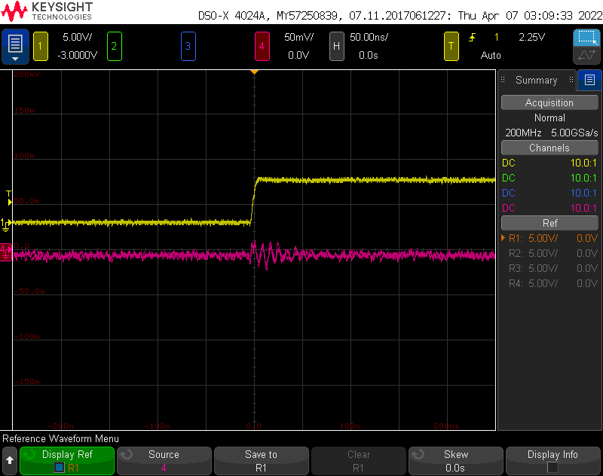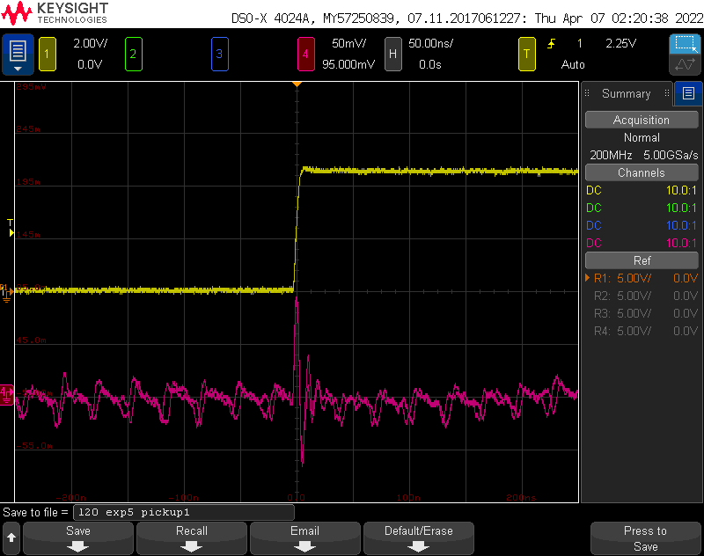

Golden Arduino

Commercial Arduino

It can be observed that Near field emission noise on Commercial arduino is around 100 mV as compared to 10mV as that of Golden Arduino

* + Inrush current measurement

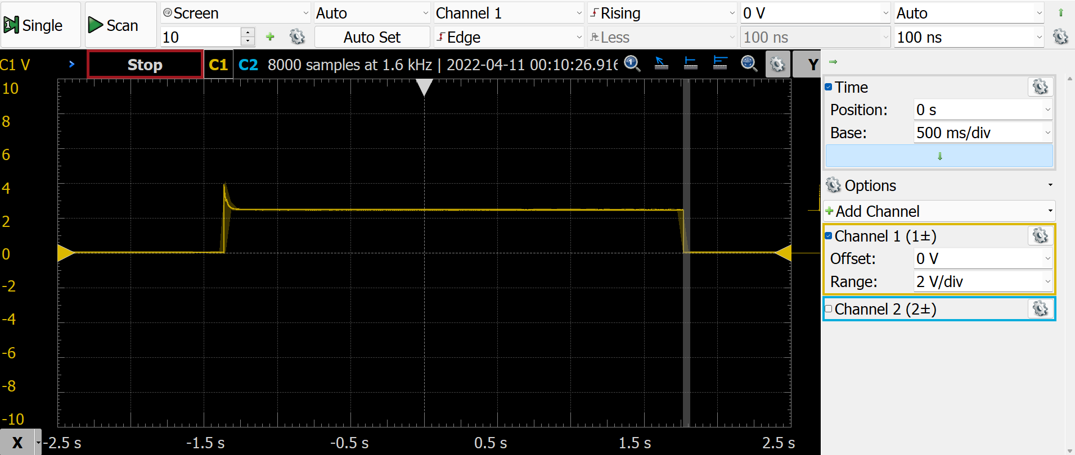

Inrush current = 4v/500mOhm = 8A  
This is majorly because of charging of decoupling capacitors + rest of the circuit.

Note: circuit is not functional when current resistor is used as voltage drop at the resistor affects rest of the circuit.

## Features of the board



Additional Rows of Ground pins

Alternative power supplies

Additional Custom switches

Ferrite Filter

Current sense resistor

Additional Custom LEDs

Ground headers are placed 300 mils apart from signal headers

6,8 and 10 pin headers match with the commercial Arduino footprint

## Demonstration of best design practices and best measurement practices

### Best design practices include:

* + - Isolation of circuits using jumper switches
    - Continuous return plane for the signals
    - Decoupling capacitor close to the IC in good layout
    - Labels for the components and test points.
    - Name and Board Identification text on the top layer
    - Ground headers close to signal pins to reduce noise induced due to loop inductance

### Best measurement practices include:

* + - Spring tip of the probe is used to reduce mutual inductance and hence the crosstalk while measurement
    - Probe was used in 10x mode and was compensated before taking the measurements.

## What did not work/Challenges

* Initially, bootloader was not getting flashed because ICSP port on commercial arduino was not working.. This was resolved using SPI pins on headers
* There was a bug in the design where filter capacitor of 22pF was used at DTR pin instead of 22uF. Because of this reset functionality though CH340g chip was not working. Manual reset using Reset pushbutton was required to flash the application code. This was resolved by replacing the capacitor to correct value.

# Analysis of your project:

## What worked and you did well and want to do in future designs

### Power supply:

1. Power LED turned on
2. Voltage measured on power rail comes around 5v
3. Voltage measured across 3.3V test point comes around 3.3 V
4. Differences in noise (crosstalk, ground bounce) was observed in commercial arduino and Golden arduino

### Atmega328:

1. Bootloader was successfully flashed to the controller
2. Application was successfully flashed to the controller
3. Oscillator for Atmega328 showed the correct frequency of 16 MHz

### CH340g

* 1. Arduino was detected as CH340g COM port in device manager
  2. Rx and Tx LEDs were blinking while flashing the microcontroller

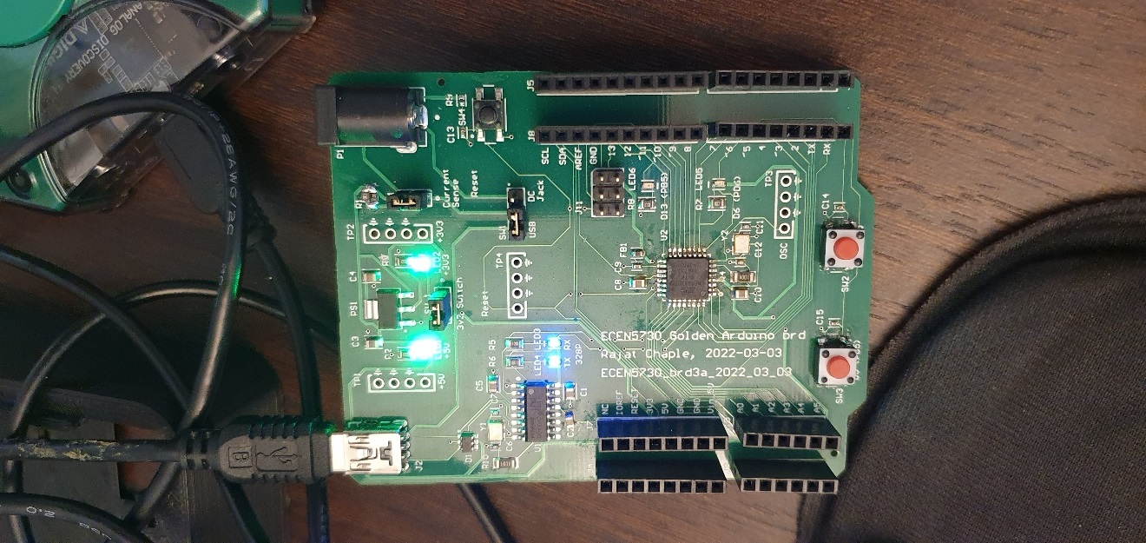

This board was built to understand Good and Bad design practices of Golden and commercial arduino. Following things were done right during this process,

* Continuous return plane for Golden Arduino
* Decoupling capacitor in the close proximity of the IC
* 6 mil trace for signals and 20 mil trace for powerlines
* Isolation switches used to isolate the power supply and digital circuit.
* Labels for the test points, components and board ID (name and description) text would be included in future designs as well
* Test points at appropriate points to measure important signals.

## What did not work, and you will want to do differently in future designs.

* + It worked as per requirement except the frequency which is off compared to theoretical value.
  + Also, there is a chance of formation of antenna due to the kind of trace drawn for the placement of decoupling capacitor in bad layout.

## Were there any hard errors- why did they go wrong

* Hard errors were corrected (Filter capacitor on DTR pin of CH340g was replaced with the correct value)

## Were there any soft errors that you would like to do differently next time?

* Critical parts could be changed to 1206 in future as these could be hand-assembled.